

SCHOOL OF COMPUTING AND INFORMATICS
BACHELOR OF SCIENCE IN INFORMATION TECHNOLOGY
UNITE TITLE: ADVANCED WEB DESIGN AND DEVELOPMENT
UNITE CODE: BIT3208
PROJECT TITLE: GYM MEMBERSHIP

SUBMITTED BY: Abraham Nathan Dennis
REG. NO: BSCCS/2024/52694

SUPERVISOR: MR. MICHAEL NYORO

IRON PULSE GYM 3
Login Page 4
Dashboard 5
INVENTORY MANAGEMENT(CRUD) 5
Inventory Module 5
Stock Inventory Page 6
CRUD OPERATIONS 6
Empty Cart 7
Select item 7
DATABASE AND GITHUB 8
Database Integration 8
phpMyAdmin Database Table 8
Database connection code 8
GitHub Version Control 9
GitHub Repository System 9
CONCLUSION 9

IRON PULSE GYM
The goal of this project was to build a fully functional Gym Membership Website connected to a local database using XAMPP.
The entire application is built using a stateless, cookie-free architecture. The system communicates dynamically with the database using direct connection strings only when data is submitted or requested.

Login Page
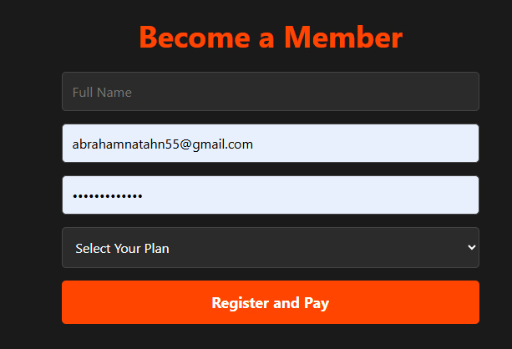
Figure 1:Login page

Dashboard
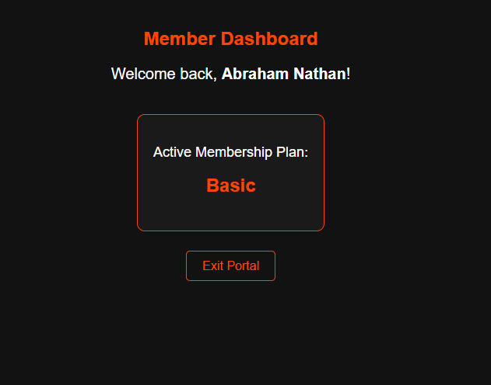
Figure 2:DASHBOARD

INVENTORY MANAGEMENT(CRUD)

Inventory Module
The inventory section stores and manages product information such as item name, stock quantity and pricing details.

Stock Inventory Page
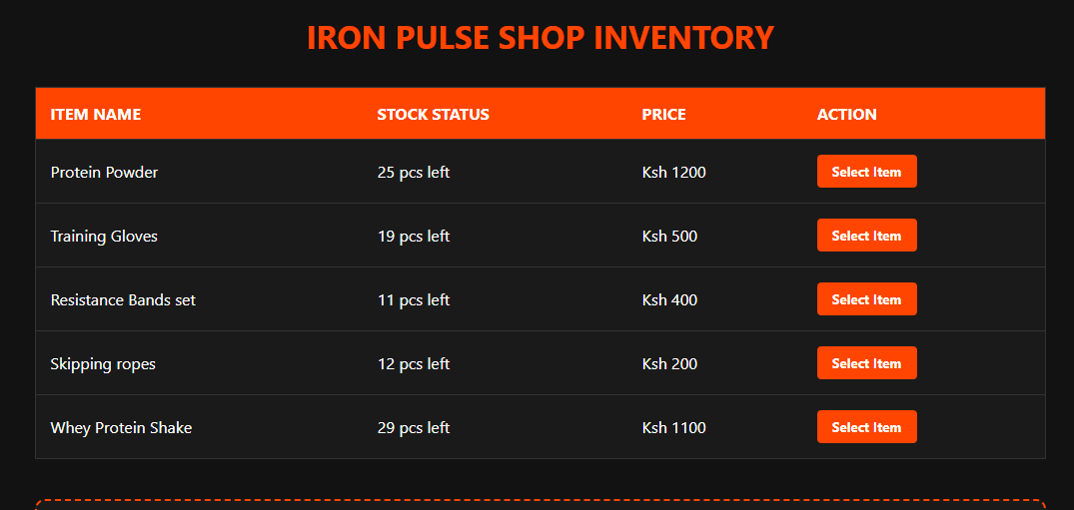

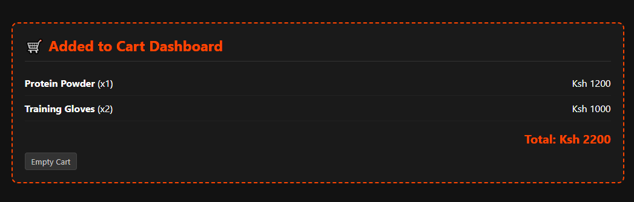
Figure 3:Stock Inventory Page

CRUD OPERATIONS
The system implements CRUD operations:
- Select items
- Shows selected items
- Sums up the total amount of products selected

Empty Cart

Figure 5:EMPTY CART

Select item

Figure 6:SELECT

DATABASE AND GITHUB

Database Integration
The system uses PHP and MySQL database connection to store, retrieve, update and manage data dynamically.

phpMyAdmin Database Table
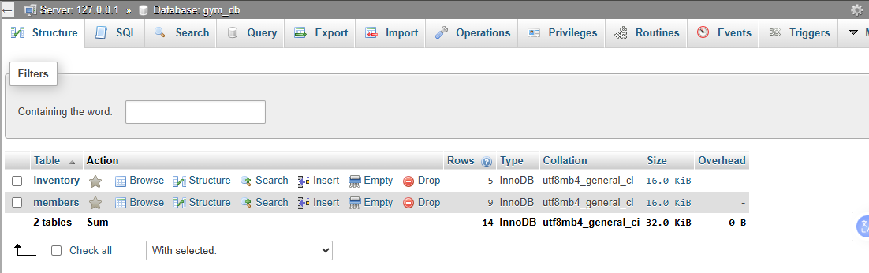
Figure 9:phpMyAdmin Database Table

Database connection code
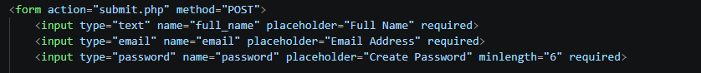
Figure 10:Database connection code

GitHub Version Control
GitHub was used to save project progress, maintain backups and track development updates.

GitHub Repository System
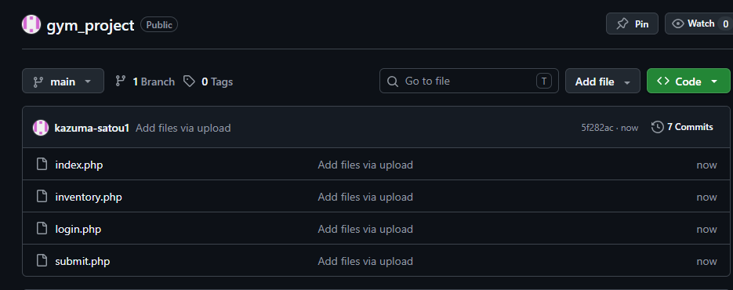
Figure 11:GitHub Repository System
https://github.com/kazuma-satou1/gym_project/tree/main
CONCLUSION
Iron Pulse successfully demonstrates backend development, database integration, authentication, inventory management and CRUD operations.
REFERENCE
- HTML:
https://www.tutorialspoint.com/html/index.htm
- CSS:
https://www.tutorialspoint.com/css/index.htm⁠
- PHP:
https://www.tutorialspoint.com/php/index.htm
- JavaScript:
https://www.tutorialspoint.com/javascript/index.htm⁠
- MySQL / Database Learning:
https://www.mysqltutorial.org/
- Git & GitHub Learning:
https://skills.github.com/⁠

https://www.zoho.com/inventory/

